Git Hands-on 1 – Git Configuration and Repository Initialization
Step 1: Configure Git
Commands Used:
git --version
git config --global user.name "katyayini2709"
git config --global user.email "baddakatyayini@gmail.com"
git config --global --list
Description:
Verified the Git installation and configured the global Git username and email address. The configuration was verified successfully using the global configuration list.
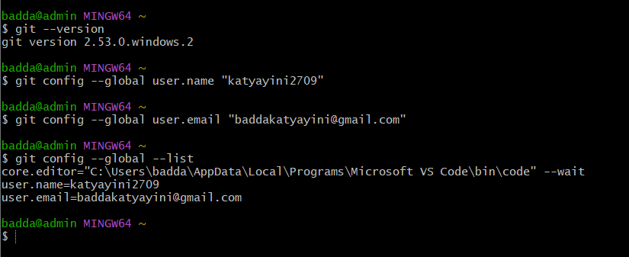
Step 2: Initialize Git Repository and Add a File
Commands Used:
git init
echo "Welcome to the version control" > welcome.txt
cat welcome.txt
git status
Description:
Initialized a new Git repository, created a sample file named welcome.txt, verified its contents, and checked the repository status. The file was displayed as an untracked file, indicating it was ready to be added to the Git repository.

